Hello again! This is Blizzard bag 3 for Life Science! How is your igloo doing? If you built an igloo as suggested in Blizzard Bag 1 you will see that, yes, it really stays an igloo all winter long.
What kind of animal lives in cold Artic weather? Is there a certain name for animals who live in very cold places?

This blizzard bag is called, “The Relationships on the Tree of Life.” I don’t know if you remember but we share 97% of our genes with chimpanzees and other animals such as fish and even plants. Wow. Aristotle was a Greek philosopher, but did you know he was a botanist too! He tried to classify as many plants and animals as he could according to their characteristics. Later, a scientist named Carolus Linnaeus from the 1800s, designed a system of naming organisms according to their physical characteristics and what they shared with other animals. This was called Linnaeus taxonomy and we still use it today!

Read the following handout “Relationships on the Tree of Life” and answer the questions on another paper. Remember use complete sentences and be thorough with your answer. First, look up some words, so you are familiar with what you are about to read:

Animalia, binomial nomenclature, cladogram, class (scientific meaning), coevolution, dichotomous key, genus, kingdom, notochord, convergent evolution, order phylum, Plantae, Protista, species and taxonomy.

Each organism is given a two-word scientific name in a system called binomial nomenclature. “Nomial” means name in and “bi” means two, so it simply means two-word naming system. Binomial nomenclature designates an organism’s genus and species and is in Latin, which allows people from all over the world to use a common language. The white tailed dear for example is called Odocoileus virginianus; the genus is Odocoileus and the species is virginianus. Genus and species names are always written Italics like this sentence. Linnaeus’s system is hierarchical, which means it groups things into seven increasingly specific groups—kingdom, phylum, class, order, family, genus, and species. The most general way to group something is by kingdom; the most specific way is by species.

Scroll down and see what further things Buckle OGT publishing has to say about taxonomy, classifying animals and Linnaeus’s system of naming organisms.

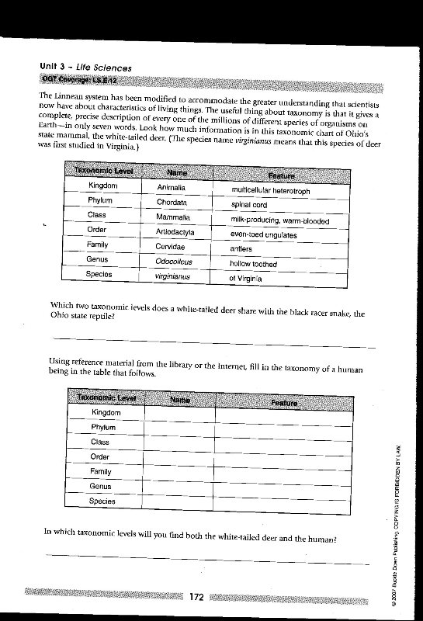
After you are done with your vocabulary and definitions read the following excerpts and answer the questions. 