Dear Parent or Guardian,

The Ohio Department of Education (ODE) would like to invite you to participate in a short, 25 question survey about your involvement in your student’s education. Research suggests that parental involvement is a key predictor of positive educational outcomes. You may be eligible to participate if your child has an IEP and receives special education services. The purpose of collecting this information is to improve services for students with disabilities across Ohio. If you are eligible to participate and you enroll in the study, you will be entered in a drawing for several $50 Amazon gift cards. Your chance of winning a gift card is approximately 2.0%. Please click on this link or use the QR (Quick Response) code (see below) to find out more about the survey and if you are eligible.

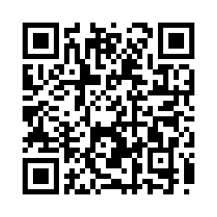

Sincerely,

David Julian, Ph.D.
Special Education Family Survey Director
(Collecting surveys on behalf of the Ohio Department of Education)

